Chapter 7, Problem 65.

If the input pulse in Fig. 7.130 (a) is applied to the circuit in Fig. 7.130 (b), determine the response i(t).

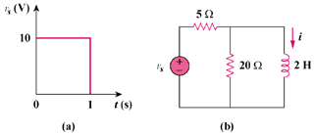

Figure 7.130
For Prob. 7.65.

